# SIR. M VISVESVARAYA INSTITUTE OF TECHNOLOGY INTERNATIONAL AIRPORT ROAD, BENGALURU,KARNATAKA-562157

MINI PROJECT REPORT ON

## “AXIOM BANKING MANAGEMENT SYSTEM”

### BACHELOR OF ENGINEERING IN

**INFORMATION SCIENCE AND ENGINEERING**

For the Academic year 2020-2021 Submitted by:

### SHASHANK KUMAR O-41

**VISHWESH PRASHAR O-22**

**VINAY KUMAR A O-32**

**PUSHKARAN HS O-03**

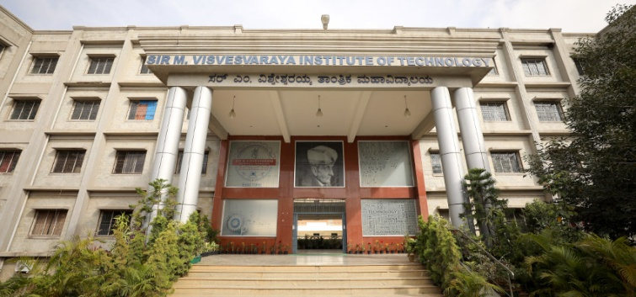

Project carried out at:

### Sir M. Visvesvaraya Institute of Technology

Bengaluru-562157

Under the guidance of:

### Mr. MANOHAR R

Assistant Professor, Department of ISE

### DR P VIJAYKARTHIK

Head of Department, ISE

# DECLARATION

We hereby declare that the entire mini project work embodied in this dissertation has been carried out by us and no part has been submitted for any degree or diploma of any institution previously.

Place: Bengaluru

Date:

Signature of Students:

SHASHANK KUMAR(O-41)

VISHWESH PRASHAR (O-22)

VINAY KUMAR A (O-32)

PUSHKARAN HS (O-03)

**TABLE OF CONTENTS**

Chapter :1 ACKNOWLEDGEMENT

Chapter :2 INTRODUCTION

2.1 Itroduction to c

2.2 Problem Statement

Chapter:3 SYSTEM REQUIREMENT

3.1 Hardware Requirement

3.2 Software Requirement

Chapter:4 SYSTEM DESIGN

4.1 Activities of DESIGN Process/System Architecture

Chapter:5 PROJECT MODULE DESCIPTION/IMPLEMENTATION

Chapter:6 CONCLUSION

6.1 conclusion

Chapter:7 REFERENCE

7.1 Reference

**Chapter:1 ACKNOWLEDGEMENT**

# ACKNOWLEDGEMENT

The dream of every engineering student is to become a competent and successful engineer in future and we are not at all exceptions. One reason behind the success of project is our sincere efforts, hard work and talent , mean while , the other main reason is the current assistance , guidance suggestions and blessings of many people. We posses a special gratitude towards them and it is our duty to express it through words.

It gives us immense pleasure to prepare this project report on the “AXIOM BANKING MANAGEMENT SYSTEM” as a mini project for the subject “C PROGRAMMING FOR PROBLEM SOLVING”.

We would like to thank our project guides Mr. MANOHAR R and others faculty from Dept of ISE for their consultative help and constructive suggestions through the course of this project. We would like to extend our gratitude to our HOD Dr. P VIJAY KARTHIK.

Finally , we would also like to thank our parents , friends and everybody who are involve in this project.

Dept. of ISE,SirMVIT 2020-2021

**CHAPTER 2 - Introduction**

**2.1 Introduction to C**

**C** is a general-purpose, procedural computer programming language supporting structured programming, lexical variable scope, and recursion, with a static type system. By design, C provides constructs that map efficiently to typical machine instructions. It has found lasting use in applications previously coded in assembly language. Such applications include operating systems and various application software for computer architectures that range from supercomputers to PLCs and embedded systems.

A successor to the programming language *B*, C was originally developed at Bell Labs by Dennis Ritchie between 1972 and 1973 to construct utilities running on Unix. It was applied to re-implementing the kernel of the Unix operating system. During the 1980s, C gradually gained popularity. It has become one of the most widely used programming languages, with C compilers from various vendors available for the majority of existing computer architectures and operating systems. C has been standardized by the ANSI since 1989 (ANSI C) and by the International Organization for Standardization (ISO).

C is an imperative procedural language. It was designed to be compiled to provide low-level access to memory and language constructs that map efficiently to machine instructions, all with minimal runtime support. Despite its low-level capabilities, the language was designed to encourage cross-platform programming. A standards-compliant C program written with portability in mind can be compiled for a wide variety of computer platforms and operating systems with few changes to its source code.

* 1. **Problem statement**

This system provides the basic services to manage bank accounts at a bank. A client opens account a bramch. Each account is uniquely identified by account number; it has a balance and a credit or overdraft limit.There are many types of accounts such as savings accounts,current accounts,fixed accounts. Bank management system would be able to maintain information and able to keep the records of that particular events.The services are:- 1.taking deposits from the customers and issuing current or checking accounts and savings accounts to individual and business. 2. Extending loans to individuals and business. 3.Cashing amount.4. all transactions will be updated automatically by usingn the information stored in record.

Dept. of ISE,SirMVIT 2020-2021

**Chapter 3 - System requirements**

**3.1 Hardware requirement**

C programming can be basically run on any workstation which has UNIX system, MS-DOS

system, Windows system, UNIX like Solaris, IRIX, GNU/Linux, BSD, Mac OS, Fedora.

All u need is as a minimum, you should have at least amount space for data and a processing RAM of good quality requirement is enough run a c programming in a system. A keyboard for a system and mouse is a basic necessity for handling a system.

**3.2 Software requirement**

There is a large amount of software on which we can run a C program. To construct a C program all we need is a **text editor** and a **C compiler**. All we need the files we create with our editor are called the source files and they contain the program source codes. The source files for C programs are typically named with the extension "**.c**".

The source code written in source file is the human readable source for your program. It needs to be "compiled", into machine language so that your CPU can actually execute the program as per the instructions given. The compiler compiles the source codes into final executable programs. The most frequently used and free available compiler is the turbo C++, otherwise you can have compilers either from HP or Solaris if you have the respective operating systems.We have used code blocks IDE.

Dept. of ISE,SirMVIT 2020-2021

**Chapter:4 SYSTEM DESIGN**

**4.1 Activities of DESIGN Process/System Architecture**

By the end of this project, you will create a fully functioning “AXIOM BANKING MANAGEMENT SYSTEM” on a console application.First we have to enter password to login into main menu.we have five functions (1.Create new account 2.Transactions 3. View customer’s list 4.Loan interest calculation 5.Exit) in main menu.You can enter in each function through enter your choice option and do the specific task.

SYNTAX USED IN CONSTRUCTION OF THIS PROJECT:

1. Introduction & use of struct
2. Use of function for specific task
3. Use of for loops
4. While loops & Do-While loops
5. Use of file pointer
6. Arrays
7. Create a fully running AXIOM BANKING MANAGEMENT SYSTEM

Dept. of ISE,SirMVIT 2020-2021

**Chapter:5 PROJECT MODULE DESCIPTION/ IMPLEMENTATION**

#include<stdio.h>

#include<stdlib.h>

#include<windows.h>

#include<conio.h>

int i,j;

int main_exit;

void menu();

struct date{

int month,day,year;

};

struct {

char name[60];

int acc_no,age;

char address[60];

char citizenship[15];

double phone;

char acc_type[10];

float amt;

struct date dob;

struct date deposit;

struct date withdraw;

}add,upd,check,rem,transaction;

void fordelay(int j)

{ int i,k;

for(i=0;i<j;i++)

k=i;

}

void new_acc()

{

int choice;

FILE *ptr;

ptr=fopen("record.dat","a+");

account_no:

system("cls");

printf("\t\t\t\xB2\xB2\xB2\ ADD RECORD \xB2\xB2\xB2\xB2");

printf("\n\n\nEnter today's date(mm/dd/yyyy):");

scanf("%d/%d/%d",&add.deposit.month,&add.deposit.day,&add.deposit.year);

printf("\nEnter the account number:");

scanf("%d",&check.acc_no);

while(fscanf(ptr,"%d %s %d/%d/%d %d %s %s %lf %s %f %d/%d/%d\n",&add.acc_no,add.name,&add.dob.month,&add.dob.day,&add.dob.year,&add.age,add.address,add.citizenship,&add.phone,add.acc_type,&add.amt,&add.deposit.month,&add.deposit.day,&add.deposit.year)!=EOF)

{

if (check.acc_no==add.acc_no)

{printf("Account no. already in use!");

fordelay(1000000000);

goto account_no;

}

}

add.acc_no=check.acc_no;

printf("\nEnter the name:");

scanf("%s",add.name);

printf("\nEnter the date of birth(mm/dd/yyyy):");

scanf("%d/%d/%d",&add.dob.month,&add.dob.day,&add.dob.year);

printf("\nEnter the age:");

scanf("%d",&add.age);

printf("\nEnter the address:");

scanf("%s",add.address);

printf("\nEnter the citizenship number:");

scanf("%s",add.citizenship);

printf("\nEnter the phone number: ");

scanf("%lf",&add.phone);

printf("\nEnter the amount to deposit:$");

scanf("%f",&add.amt);

printf("\nType of account:\n\t#Saving\n\t#Current\n\t#Fixed1(for 1 year)\n\t#Fixed2(for 2 years)\n\t#Fixed3(for 3 years)\n\n\tEnter your choice:");

scanf("%s",add.acc_type);

fprintf(ptr,"%d %s %d/%d/%d %d %s %s %lf %s %f %d/%d/%d\n",add.acc_no,add.name,add.dob.month,add.dob.day,add.dob.year,add.age,add.address,add.citizenship,add.phone,add.acc_type,add.amt,add.deposit.month,add.deposit.day,add.deposit.year);

fclose(ptr);

printf("\nAccount created successfully!");

add_invalid:

printf("\n\n\n\t\tEnter 1 to go to the main menu and 0 to exit:");

scanf("%d",&main_exit);

system("cls");

if (main_exit==1)

menu();

else if(main_exit==0)

close();

else

{

printf("\nInvalid!\a");

goto add_invalid;

}

}

void view_list()

{

FILE *view;

view=fopen("record.dat","r");

int test=0;

system("cls");

printf("\nACC. NO.\tNAME\t\t\tADDRESS\t\t\tPHONE\n");

while(fscanf(view,"%d %s %d/%d/%d %d %s %s %lf %s %f %d/%d/%d",&add.acc_no,add.name,&add.dob.month,&add.dob.day,&add.dob.year,&add.age,add.address,add.citizenship,&add.phone,add.acc_type,&add.amt,&add.deposit.month,&add.deposit.day,&add.deposit.year)!=EOF)

{

printf("\nAccount NO.:%d\nName:%s \nDOB:%d/%d/%d \nAge:%d \nAddress:%s \nCitizenship No:%s \nPhone number:%.0lf \nType Of Account:%s \nAmount deposited:$ %.2f \nDate Of Deposit:%d/%d/%d\n\n",add.acc_no,add.name,add.dob.month,add.dob.day,add.dob.year,add.age,add.address,add.citizenship,add.phone,

add.acc_type,add.amt,add.deposit.month,add.deposit.day,add.deposit.year);

test++;

}

fclose(view);

if (test==0)

{ system("cls");

printf("\nNO RECORDS!!\n");}

view_list_invalid:

printf("\n\nEnter 1 to go to the main menu and 0 to exit:");

scanf("%d",&main_exit);

system("cls");

if (main_exit==1)

menu();

else if(main_exit==0)

close();

else

{

printf("\nInvalid!\a");

goto view_list_invalid;

}

}

void transact(void)

{ int choice,test=0;

FILE *old,*newrec;

old=fopen("record.dat","r");

newrec=fopen("new.dat","w");

printf("Enter the account no. of the customer:");

scanf("%d",&transaction.acc_no);

while (fscanf(old,"%d %s %d/%d/%d %d %s %s %lf %s %f %d/%d/%d",&add.acc_no,add.name,&add.dob.month,&add.dob.day,&add.dob.year,&add.age,add.address,add.citizenship,&add.phone,add.acc_type,&add.amt,&add.deposit.month,&add.deposit.day,&add.deposit.year)!=EOF)

{

if(add.acc_no==transaction.acc_no)

{ test=1;

if(strcmpi(add.acc_type,"fixed1")==0||strcmpi(add.acc_type,"fixed2")==0||strcmpi(add.acc_type,"fixed3")==0)

{

printf("\a\a\a\n\nYOU CANNOT DEPOSIT OR WITHDRAW CASH IN FIXED ACCOUNTS!!!!!");

fordelay(1000000000);

system("cls");

menu();

}

printf("\n\nDo you want to\n1.Deposit\n2.Withdraw?\n\nEnter your choice(1 for deposit and 2 for withdraw):");

scanf("%d",&choice);

if (choice==1)

{

printf("Enter the amount you want to deposit:$ ");

scanf("%f",&transaction.amt);

add.amt+=transaction.amt;

fprintf(newrec,"%d %s %d/%d/%d %d %s %s %lf %s %f %d/%d/%d\n",add.acc_no,add.name,add.dob.month,add.dob.day,add.dob.year,add.age,add.address,add.citizenship,add.phone,add.acc_type,add.amt,add.deposit.month,add.deposit.day,add.deposit.year);

printf("\n\nDeposited successfully!");

}

else

{

printf("Enter the amount you want to withdraw:$ ");

scanf("%f",&transaction.amt);

add.amt-=transaction.amt;

fprintf(newrec,"%d %s %d/%d/%d %d %s %s %lf %s %f %d/%d/%d\n",add.acc_no,add.name,add.dob.month,add.dob.day,add.dob.year,add.age,add.address,add.citizenship,add.phone,add.acc_type,add.amt,add.deposit.month,add.deposit.day,add.deposit.year);

printf("\n\nWithdrawn successfully!");

}

}

else

{

fprintf(newrec,"%d %s %d/%d/%d %d %s %s %lf %s %f %d/%d/%d\n",add.acc_no,add.name,add.dob.month,add.dob.day,add.dob.year,add.age,add.address,add.citizenship,add.phone,add.acc_type,add.amt,add.deposit.month,add.deposit.day,add.deposit.year);

}

}

fclose(old);

fclose(newrec);

remove("record.dat");

rename("new.dat","record.dat");

if(test!=1)

{

printf("\n\nRecord not found!!");

transact_invalid:

printf("\n\n\nEnter 0 to try again,1 to return to main menu and 2 to exit:");

scanf("%d",&main_exit);

system("cls");

if (main_exit==0)

transact();

else if (main_exit==1)

menu();

else if (main_exit==2)

close();

else

{

printf("\nInvalid!");

goto transact_invalid;

}

}

else

{

printf("\nEnter 1 to go to the main menu and 0 to exit:");

scanf("%d",&main_exit);

system("cls");

if (main_exit==1)

menu();

else

close();

}

}

void close(void)

{

printf("\n\n\n\nTHANK YOU! FOR BANKING WITH US");

getch();

}

void interest()

{

printf("TERMS AND CONDITION\nREAD ALL SCHEME RELATED DOCUMENTS CAREFULLY\nCOLLATERAL IS REQUIRED FOR LOAN\n MINIMUM 99999 AMOUNT MUST BE THERE IN YOUR ACCOUNT TO TAKE LOAN\n");

printf("4 PERCENT INTEREST WILL BE TAKEN ON AMOUNT LESS THAN 500000\n7 PERCENT INTEREST WILL BE TAKEN ON AMOUNT MORE THAN 499999\n\n\n\n\n");

int money,rate;

float time;

printf("enter loan amount: ");

scanf("%d",&money);

printf("enter time period in months: ");

scanf("%f",&time);

time=time/12.000;

if(money<500000)

{

rate=4;

}

else if(money>499999)

{

rate=7;

}

float SI;

SI=(rate*time*money)/100.0;

printf("SIMPLE INTEREST: %f ",SI);

printf("\nEnter 1 for main menu and 0 to exit:");

scanf("%d",&main_exit);

if (main_exit==1)

{

system("cls");

menu();

}

else if (main_exit==0)

{

system("cls");

close();}

getch();

}

void menu(void)

{ int choice;

system("cls");

system("color 9");

printf("\n\n\t\t\tWELCOME TO AXIOM BANKING SYSTEM");

printf("\n\n\n\t\t\t WELCOME TO THE MAIN MENU");

printf("\n\n\t\t1.Create new account\n\t\t2.For transactions\n\t\t3.View customer's list\n\t\t4.LOAN INTEREST CALCULATION\n\t\t5.Exit\n\n\n\n\n\t\t Enter your choice:");

scanf("%d",&choice);

system("cls");

switch(choice)

{

case 1:new_acc();

break;

case 2:transact();

break;

case 3:view_list();

break;

case 4:interest();

break;

case 5:close();

break;

}

}

int main()

{

char pass[10],password[10]="axiom";

int i=0;

printf("\n\n\t\tEnter the password to login:");

scanf("%s",pass);

if (strcmp(pass,password)==0)

{printf("\n\nPassword Match!\nLOADING");

for(i=0;i<=6;i++)

{

fordelay(100000000);

printf(".");

}

system("cls");

menu();

}

else

{ printf("\n\nWrong password!!\a\a\a");

login_try:

printf("\nEnter 1 to try again and 0 to exit:");

scanf("%d",&main_exit);

if (main_exit==1)

{

system("cls");

main();

}

else if (main_exit==0)

{

system("cls");

close();}

else

{printf("\nInvalid!");

fordelay(1000000000);

system("cls");

goto login_try;}

}

return 0;

}

**OUTPUTS:**

**THIS IS OPENING WINDOW: Here we have to enter password to login in to main menu.**

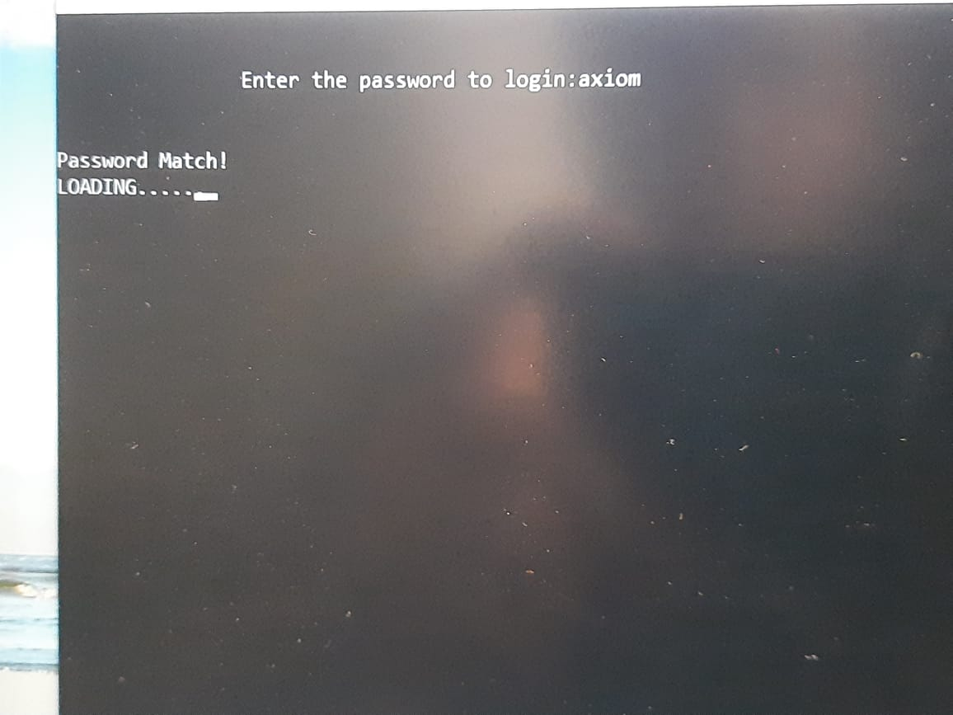

This is main menu of the program here you have to enter your choice

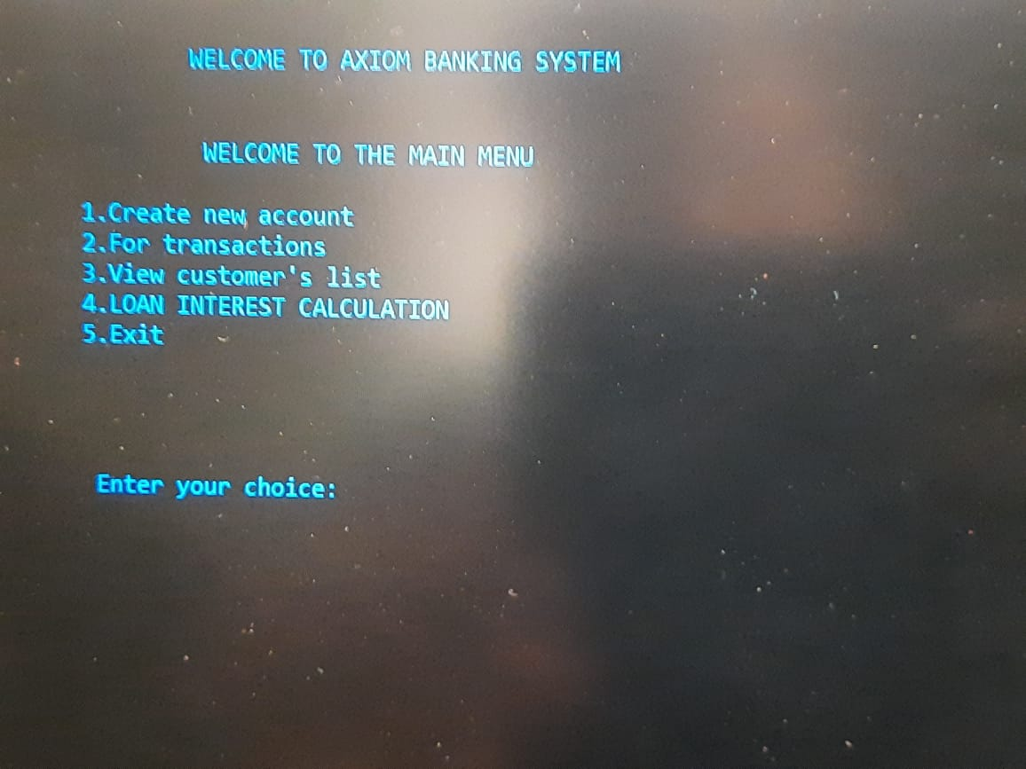

We have to enter 1 to go to create new account

There you can enter you details .

* SOME DETAILS ARE AS FOLLW:-
* NAME
* ACCOUNT NO
* CITIZENSHIP NO
* TYPE OF ACCOUNT

Dept. of ISE,SirMVIT 2020-2021

YOU CAN SEE THAT THIS ACCOUNT IS OF A CLIENT NAME ADI

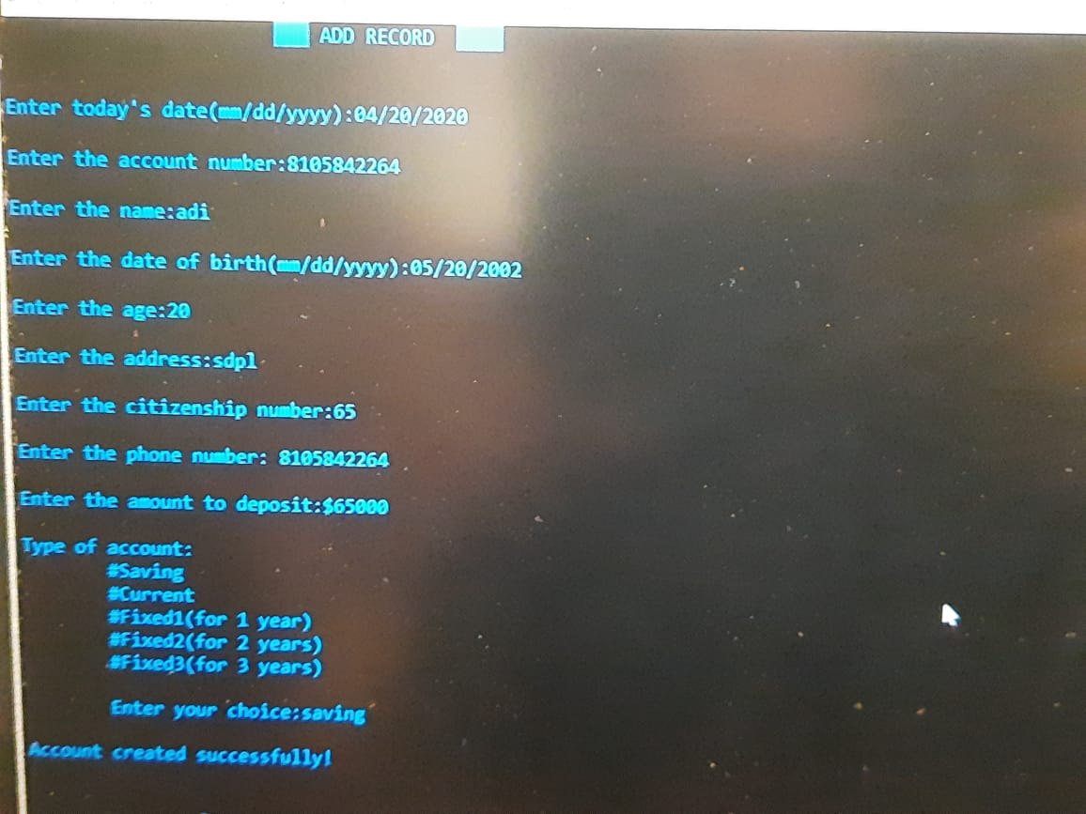

AFTER THAT RETURN TO MAIN MENU

ENTER 2 FOR TRANSACTIONS(DEPOSIT,WITHDRAW)

FOR DEPOSIT(CHOICE 1) TO WITHDRAW(CHOICE 2)

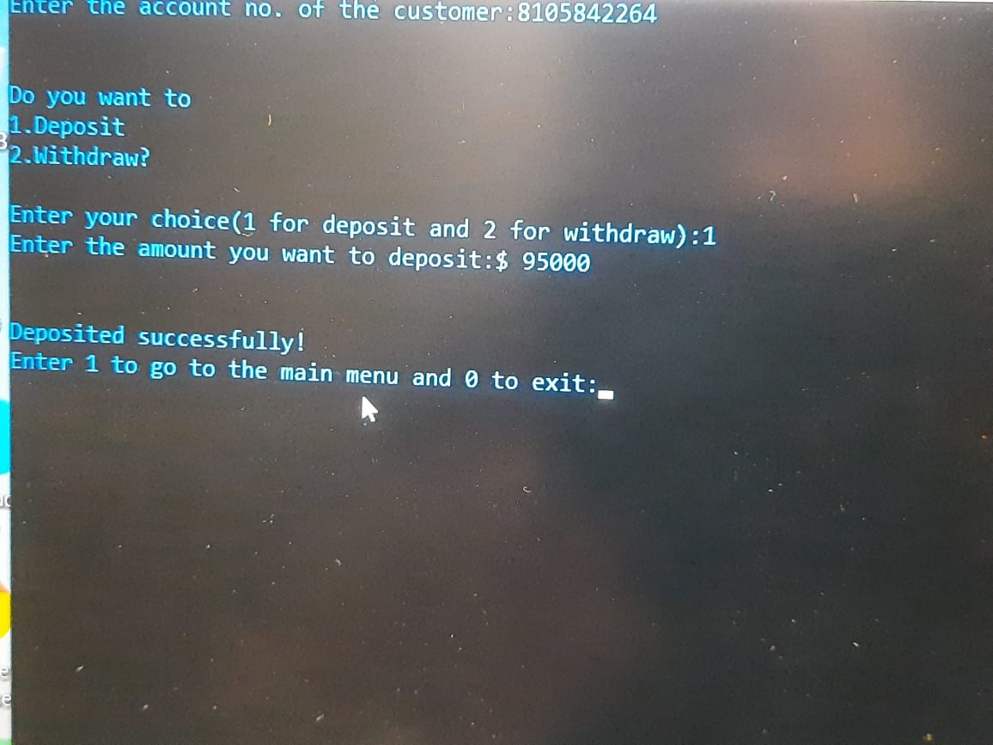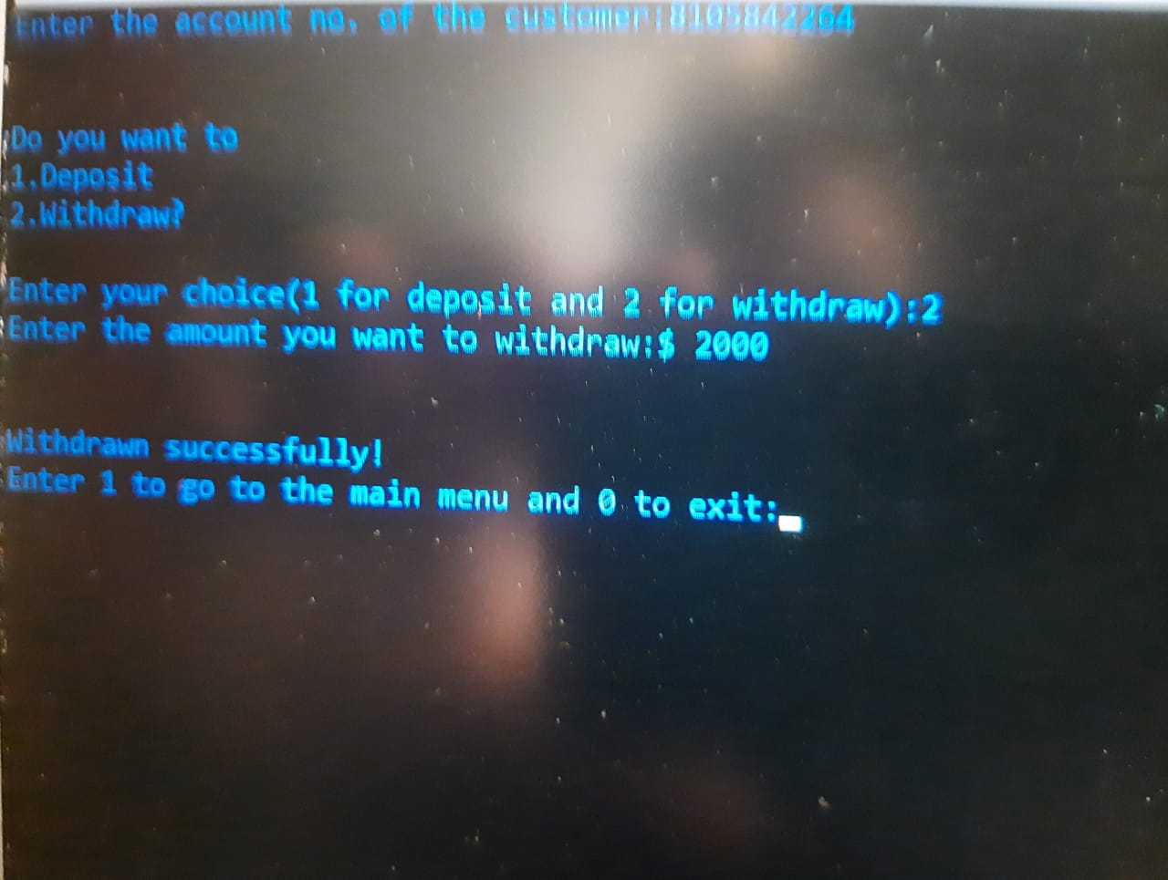

AFTER THAT RETURN TO MAIN MENU

ENTER 3 TO VIEW CUSTOMER LIST

ALL THE CUSTOMERS AND THEIR DETAILS WILL BE SHOWN

THE IMAGE BELOW SHOWS THE CUSTOMER LIST WINDOW

Dept. of ISE,SirMVIT 2020-2021

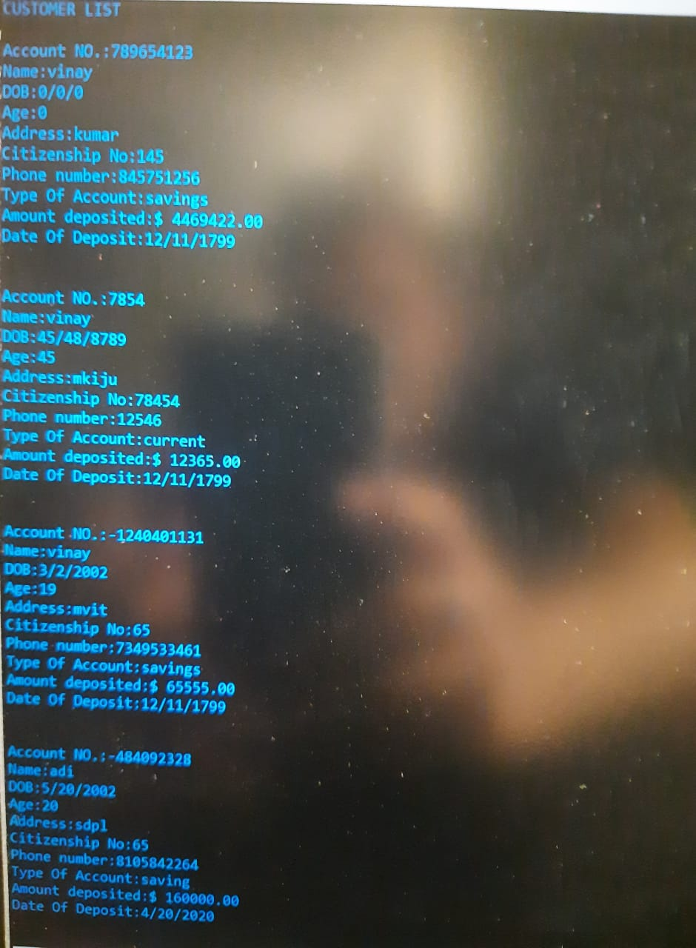

AFTER THAT RETURN TO MAIN MENU

ENTER 4 TO CALCULATE LOAN INTEREST

PLEASE READ THE TERMS AND CONDITION CAREFULLY

ENTER AMOUNT AND TIME(IN MONTHS) FOR WHICH YOU HAVE TO TAKE LOAN

THE BELOW IMAGE SHOWS THE INTEREST CALCULATION OF A USER WHOSE AMOUNT IS 10000000 AND TAKEN LOAN FOR 5 MONTHS.

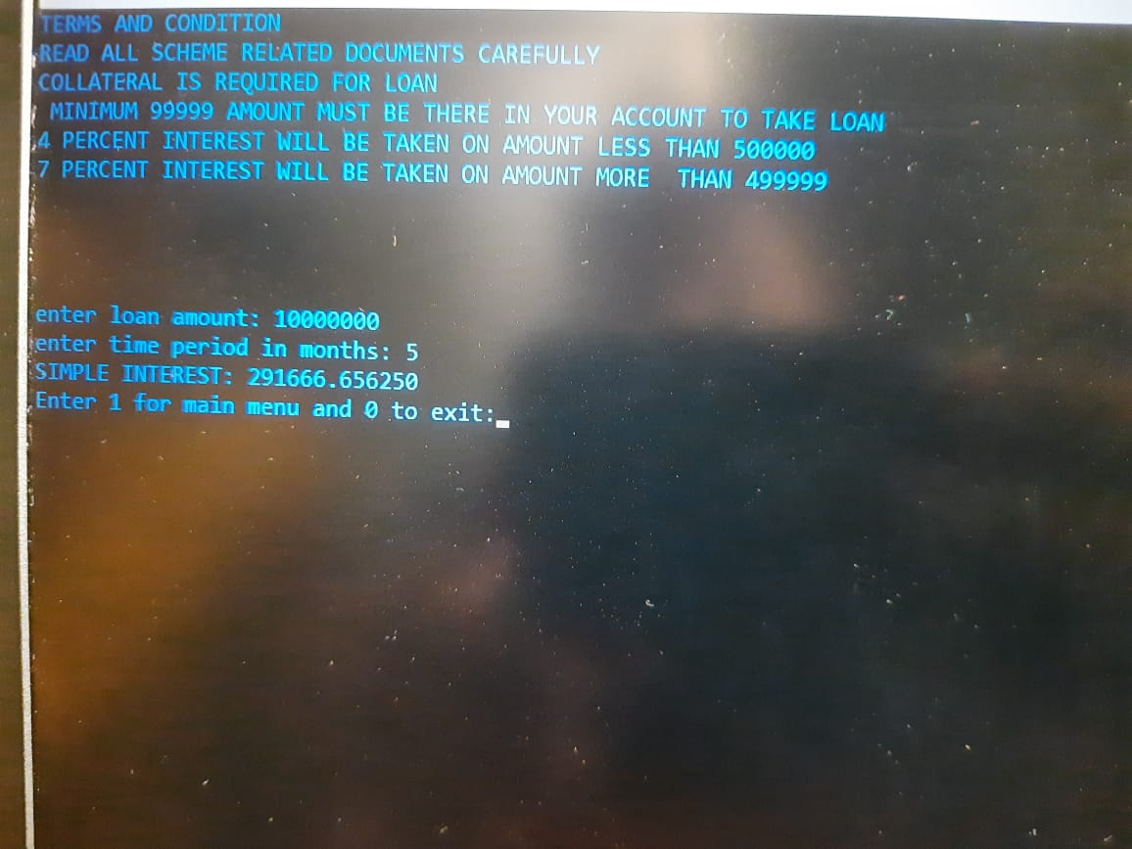

RETURN TO MAIN MENU BY ENTERING 1

AFTER THAT YOU CAN CHOOSE EXIT BUTTON FROM MAIN MENU BY ENTERING 5

A MESSAGE SAYING THANK YOU! FOR BANKING WITH US WILL APPEAR ON THE CONSOLE WINDOW

THE IMAGE BELOW SHOWS THE MESSAGE

Dept. of ISE,SirMVIT 2020-2021

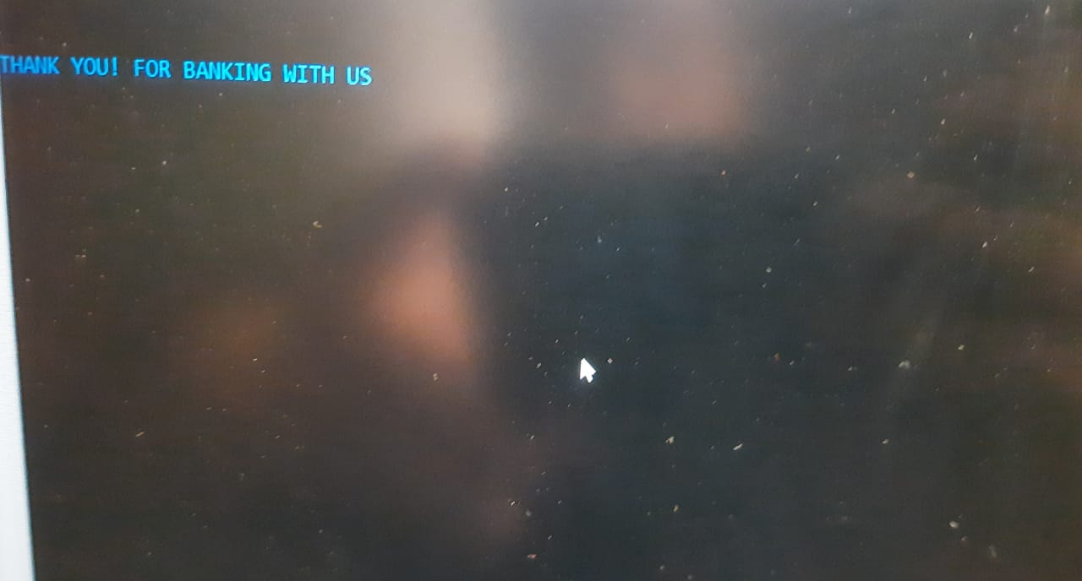

**Chapter:6 CONCLUSION**

**6.1 Conclusion**

We have gained immense experience and knowledge in making this project we have noted our mistakes and strength throughout the project even a small line of code has given a boost to our confidence to code.we have noted our mistakes and learnt about new syntaxes in c.c is an old but very efficient language for begineers.we have enjoyed working together as a team and noted the advantage of team work.we have also taken help from faculty of our college.special gratitude to MANOHAR SIR and HOD P.VIJAYKARTHIK .

**Chapter:7 REFERENCE**

**7.1 Reference**

**1.** [**https://www.codewithc.com/**](https://www.codewithc.com/)

**2.**[**https://www.learn-c.org/**](https://www.learn-c.org/)

**3.**[**https://www.coursera.org/courses?query=c%20programming**](https://www.coursera.org/courses?query=c%20programming)

**4.** [**https://www.freecodecamp.org/**](https://www.freecodecamp.org/)

Dept. of ISE,SirMVIT 2020-2021

~~~~~~~~~~~~~~~~~~~~~~~~~~~~~~~~~~~~~~~~~~~~~~~~~~~~~~~~~~~~~~~



**SIR M. VISVESVARAYA INSTITUTE OF TECHNOLOGY**

**DEPARTMENT OF INFORMATION SCIENCE AND ENGINEERING**

**Hunasamaranahalli, Bengaluru -562157**

**CERTIFICATE**

This is to certify that this project report entitled "AXIOM BANKING MANAGEMENT SYSTEM" by Shashank Kumar,Vishwesh Prashar,Vinay Kumar A and Pushkaran HS submitted in partial fulfillment of the requirements for the degree of Bachelor of Engineering in Information Science and Engineering of Sir M. Visvesvaraya Institute of Technology, Bengaluru, during the academic year 2020-2021, is a bona fide record of work carried out in a satisfactory way

Project Guide Project Guide

Manohar R Dr. P. Vijaykarthik

Asst. Prof., Dept. of ISE HOD,Dept. of ISE

Sir MVIT, Bengaluru Sir MVIT, Bengaluru